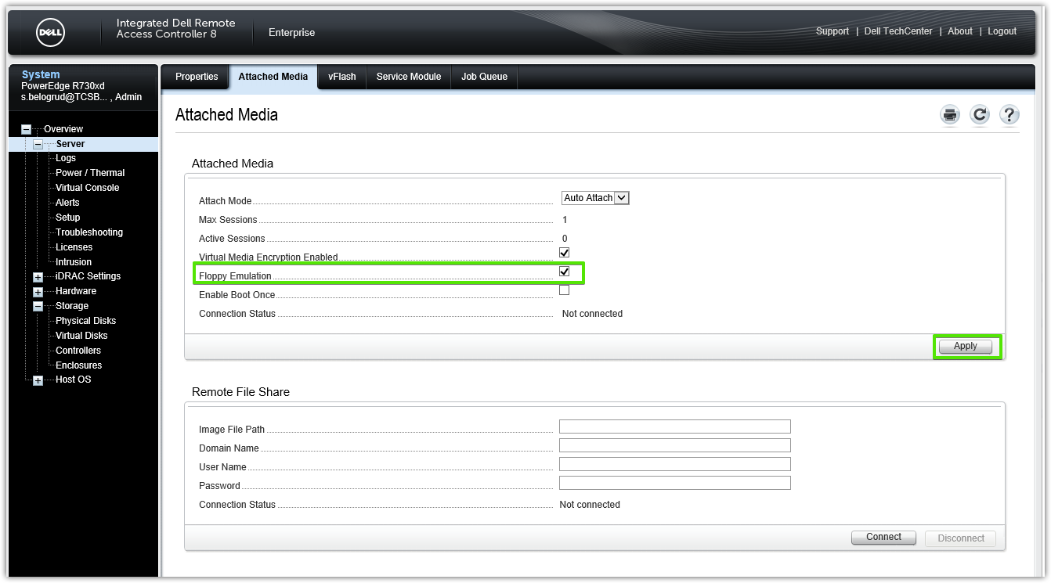

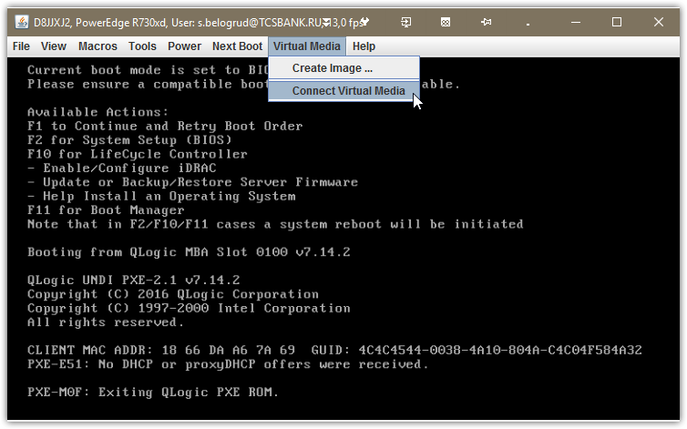

# Applying that checkbox allow as to see “Map floppy …”.
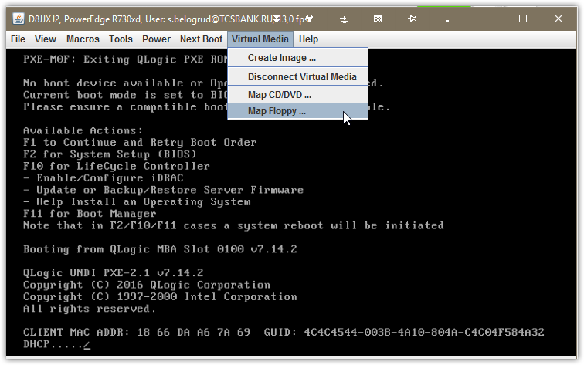

# Without that option, we will see only “Map Removable Disk …”.
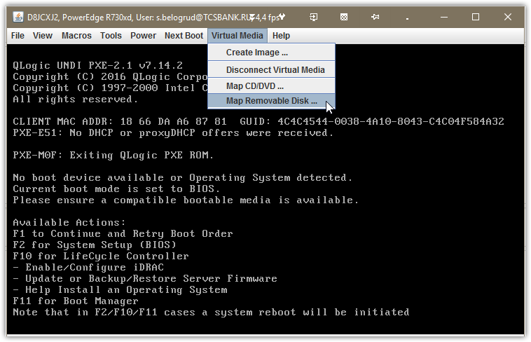

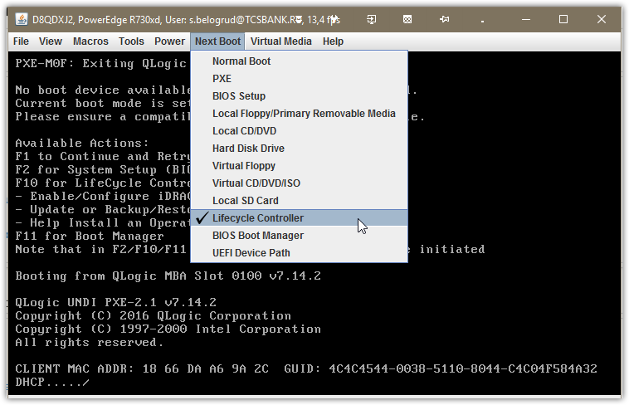

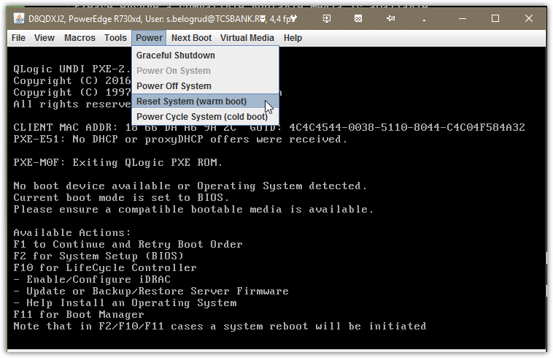

# This is a wizard to configure Lifecycle Controller. We need not this config.
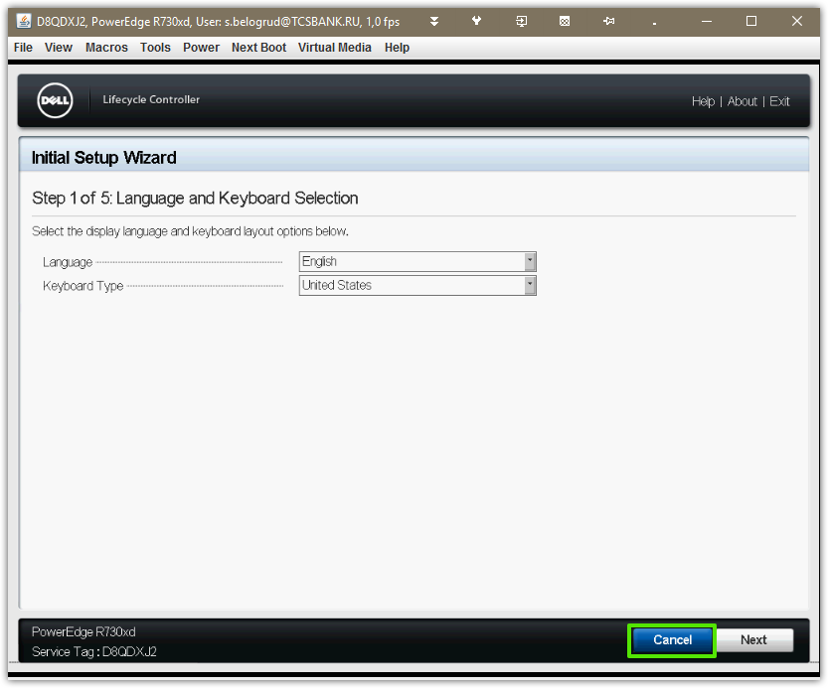

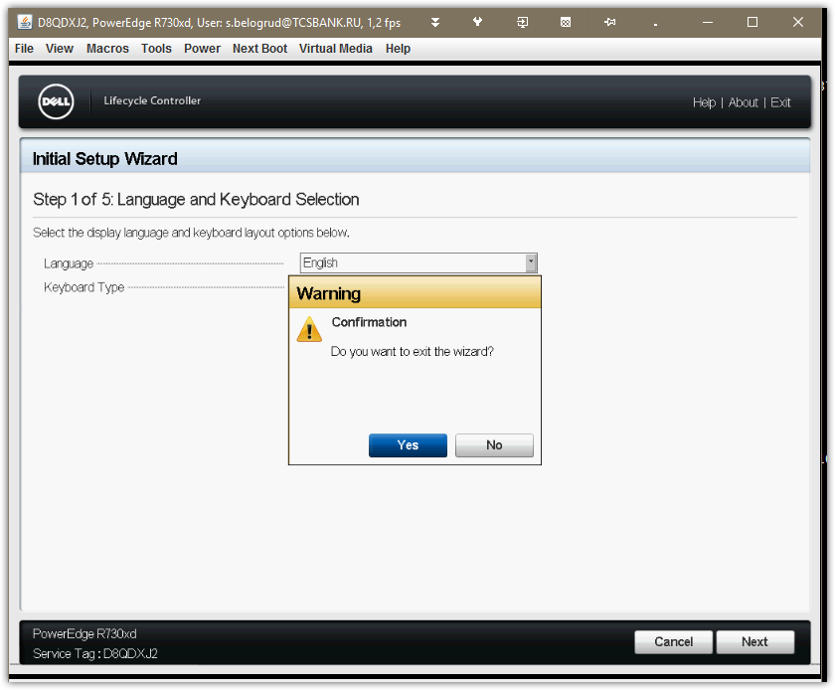

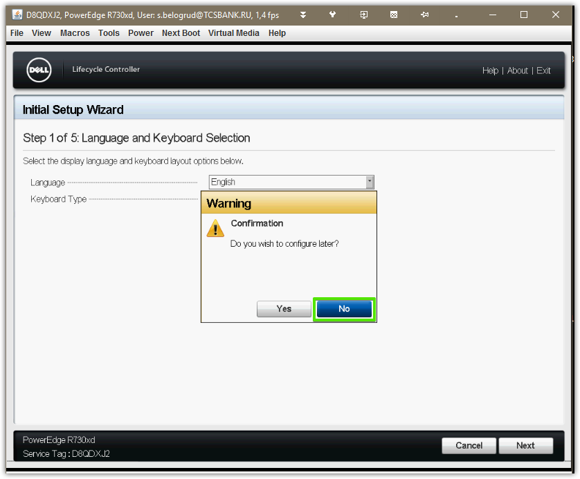

# At this point I’ve added media images.
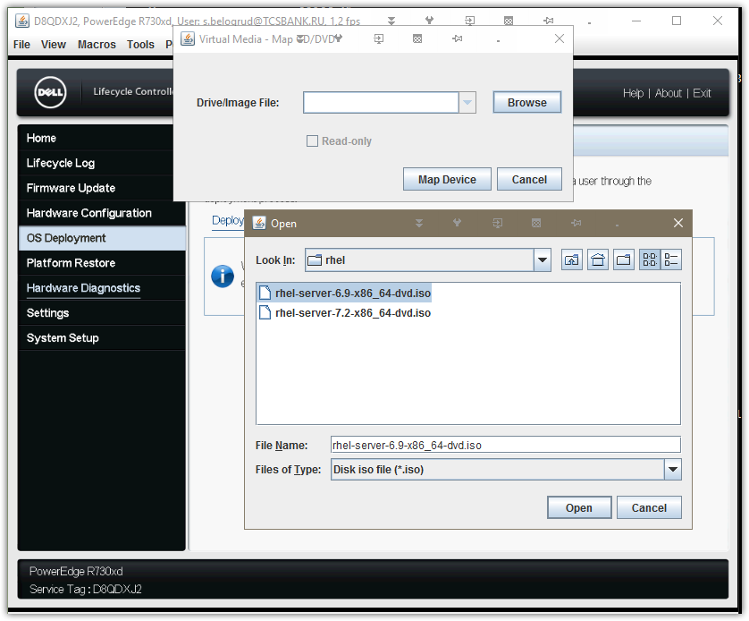

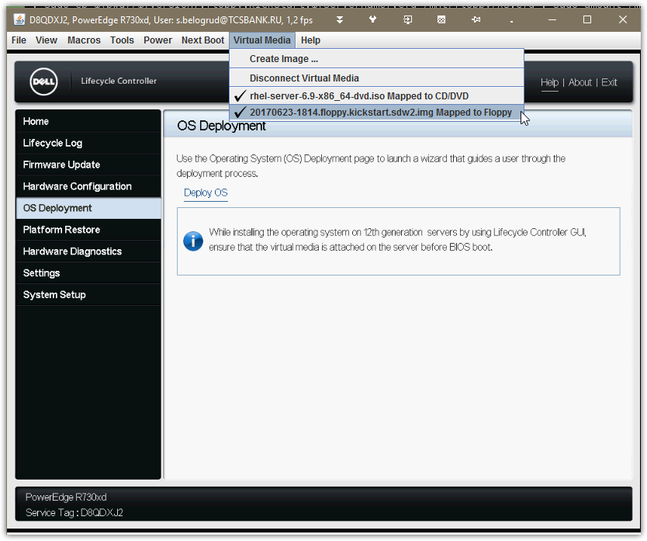

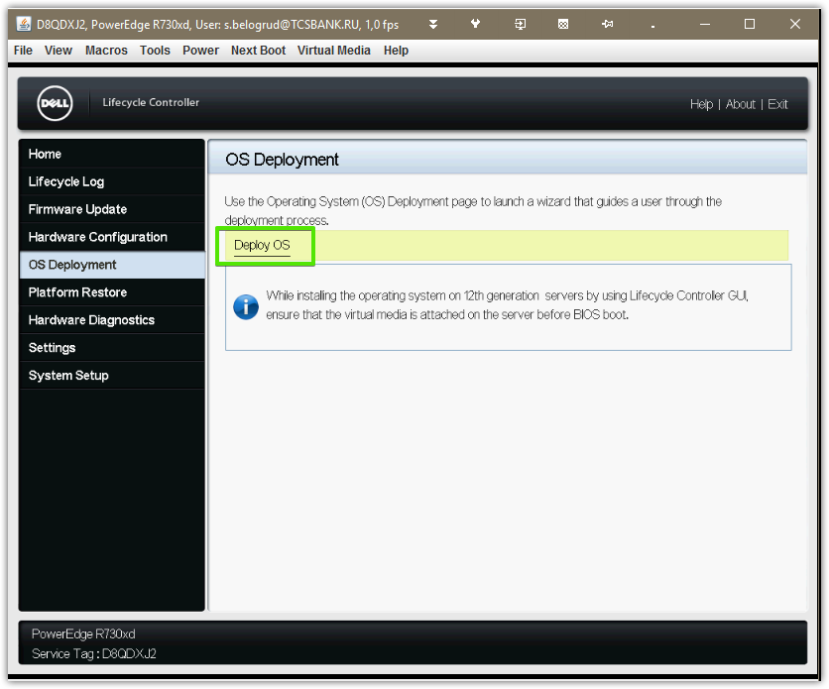

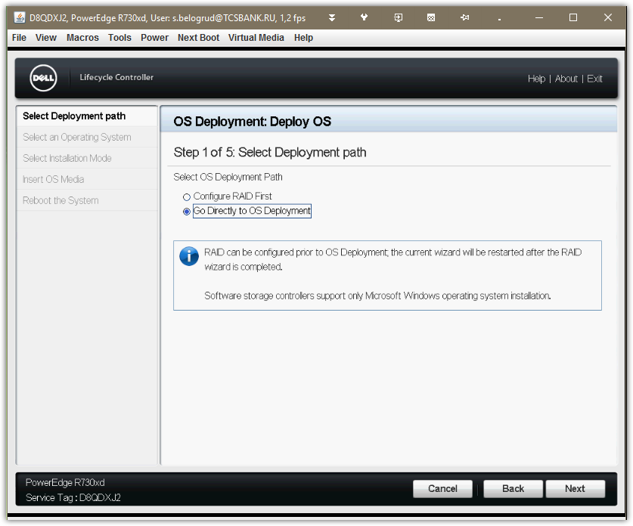

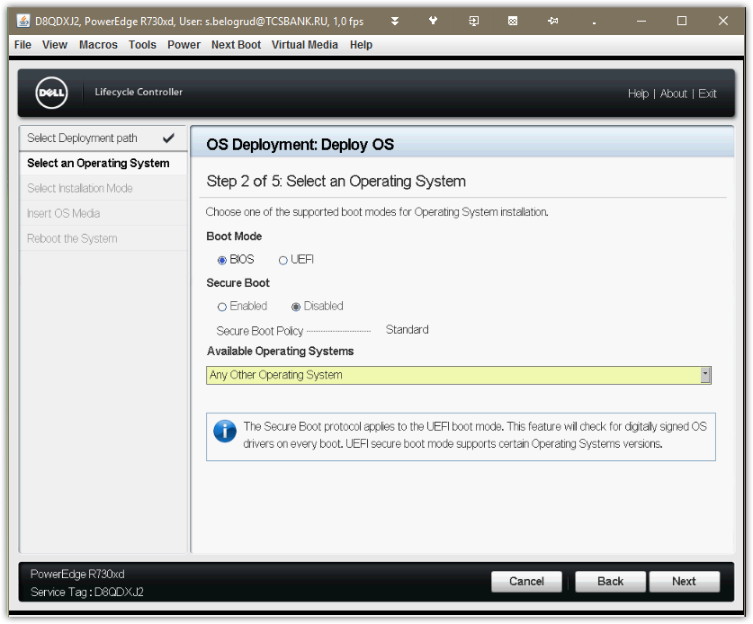

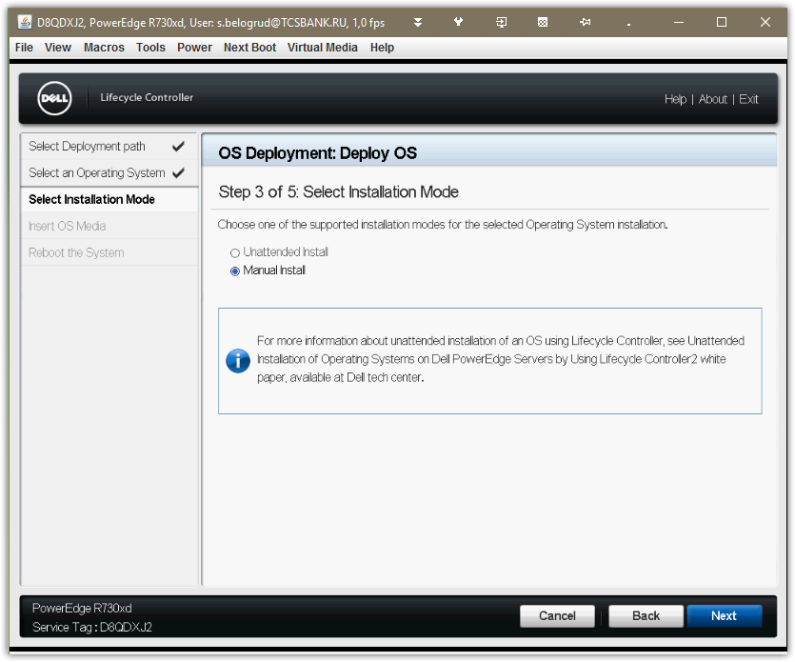

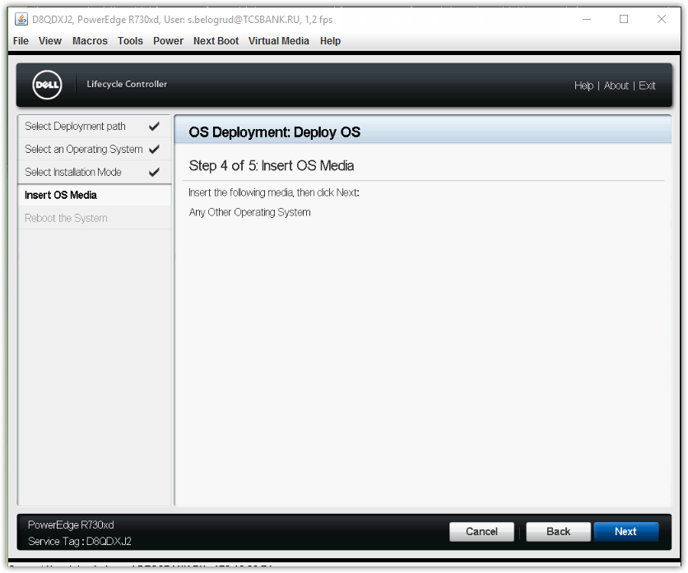

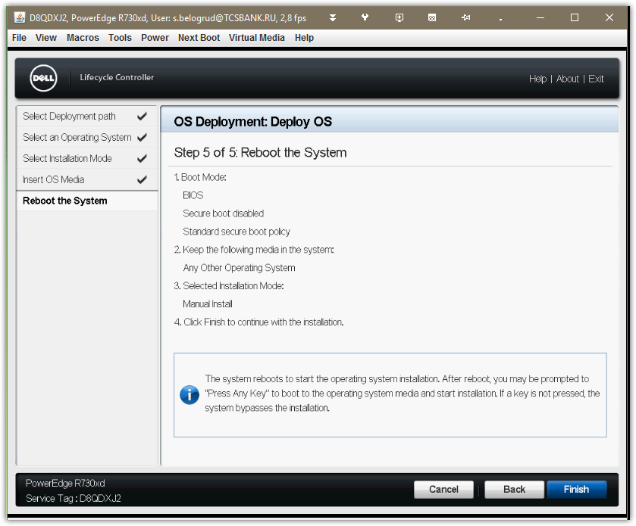

# Here we need to write follow “ks=hd:sdb:/ks.cfg”.
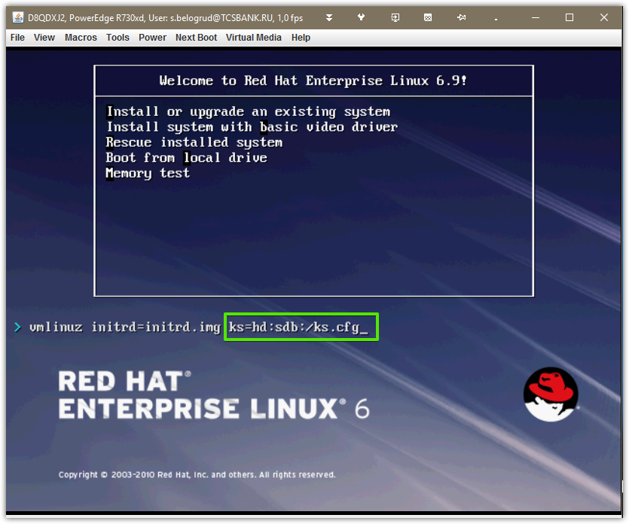

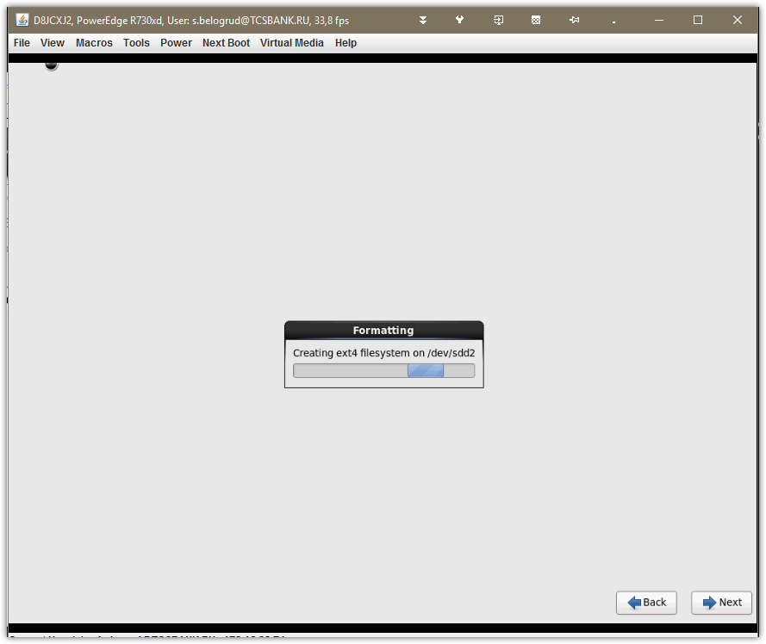

# Press “Continue” button.
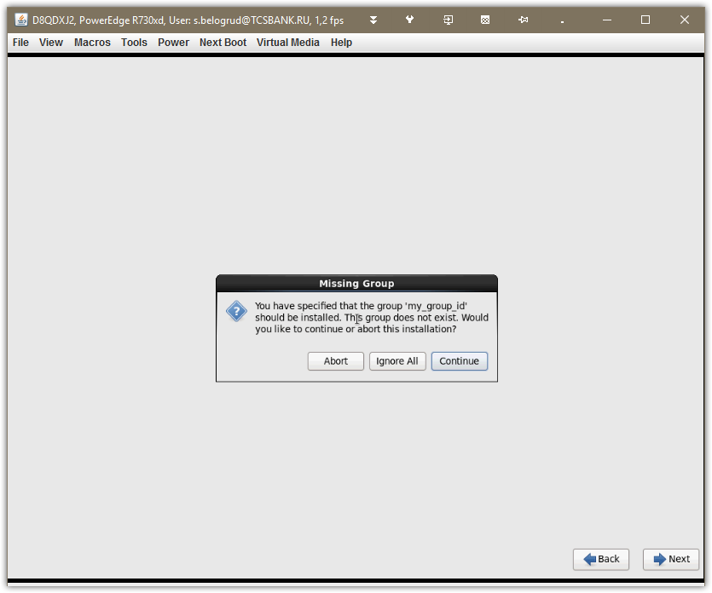

# After 30 seconds will appera black box with information, that media was found and continue installation.
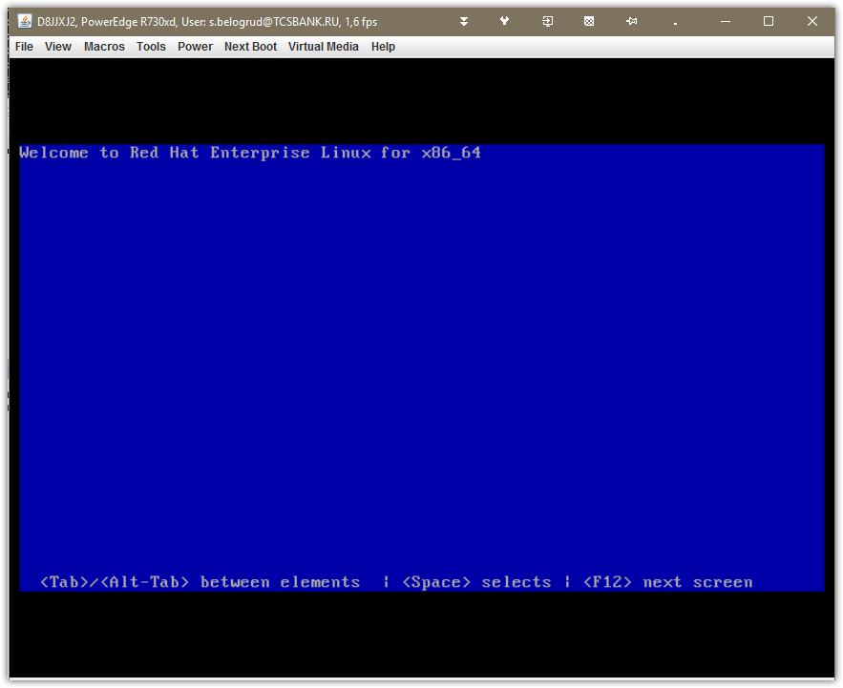

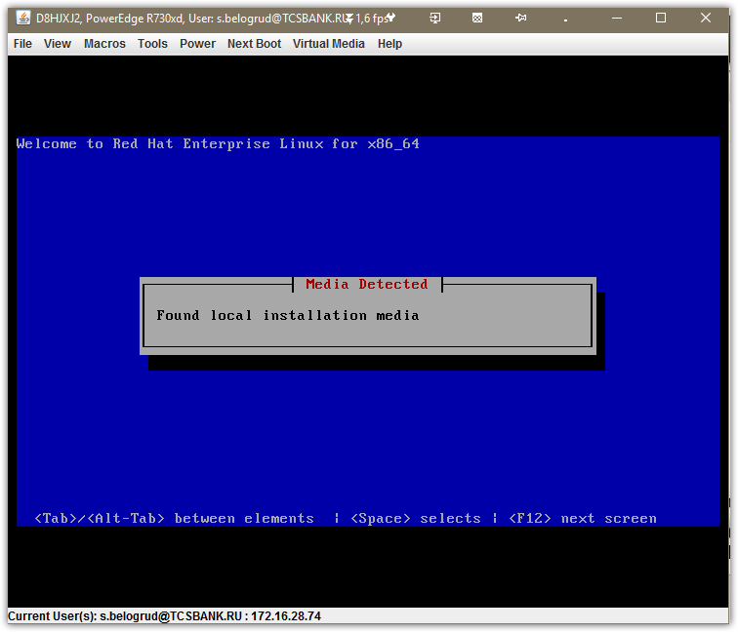

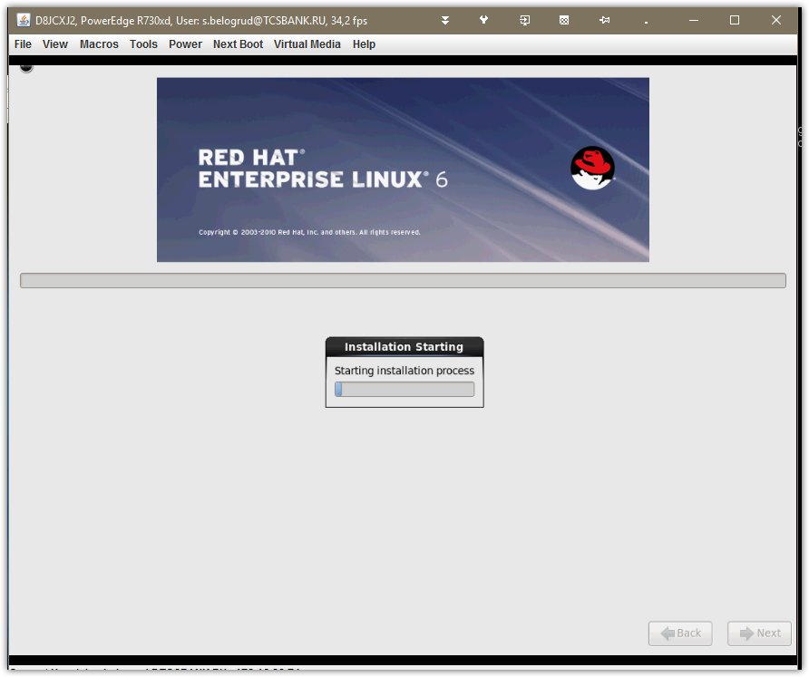

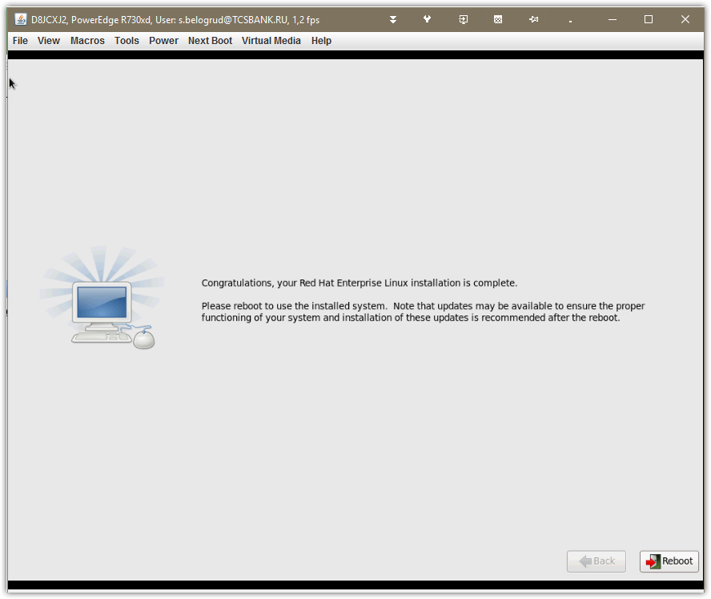

# Next step is reboot and remove inserted virtual media.

[2017-06-28 17:25.35] ~
[s.belogrud.TCS4357] ➤ cat /drives/c/share/20170623-1814.floppy.kickstart.sdw1.cfg
install
cdrom
lang en_US.UTF-8
keyboard us
network --onboot yes --device em1 --noipv4 --noipv6 --hostname m1-2-gp-prd-sdw1
network --onboot yes --device em2 --noipv4 --noipv6
network --onboot no --device em3 --bootproto dhcp --noipv6
network --onboot no --device em4 --bootproto dhcp --noipv6
rootpw --iscrypted $6$YYVDyPO4YH7lPH.J$anrXuNmljhRTa/dylnJv2eeAQ3GLnu5m6MarudWhnZVIdWbZ2qpWP9CFobF/ePYzzQvK5s57RZCbng5uBjz.H.
firewall --disabled
authconfig --enableshadow --passalgo=sha512
selinux --disabled
timezone Europe/Moscow
logging --level=info
bootloader --location=mbr --driveorder=sdd --append="crashkernel=auto rhgb quiet"
# The following is the partition information you requested
# Note that any partitions you deleted are not expressed
# here so unless you clear all partitions first, this is
# not guaranteed to work
clearpart --all --initlabel
zerombr
part /boot --asprimary --fstype="ext2" --ondisk=sdd --size=500
part / --asprimary --fstype="ext4" --ondisk=sdd --size=200 --grow

part /gpcat --asprimary --fstype="xfs" --ondisk=sdc --size=200 --grow
part /data1 --asprimary --fstype="xfs" --ondisk=sde --size=200 --grow
part /duet --asprimary --fstype="xfs" --ondisk=sdf --size=200 --grow
part /data2 --asprimary --fstype="xfs" --ondisk=sdg --size=200 --grow

repo --name="Driver Disk 0" --baseurl=file://anaconda-addon

%packages
@base
@client-mgmt-tools
@console-internet
@core
@debugging
@directory-client
@hardware-monitoring
@java-platform
@large-systems
@network-file-system-client
@performance
@perl-runtime
@server-platform
@server-policy
@my_group_id
pax
python-dmidecode
oddjob
sgpio
device-mapper-persistent-data
samba-winbind
certmonger
pam_krb5
krb5-workstation
perl-DBD-SQLite

#usefull utils
mc
screen
telnet
vim-enhanced
system-config-date
sysstat
sos
sysfsutils

# Other useful utils.
perl-XML-Parser
net-snmp
net-snmp-perl
net-snmp-utils
ntp
strace
ncompress
ruby
sysstat

#PCI DSS packages
audit

########################################################
%post --nochroot --interpreter /bin/sh

#log file
log(){
echo "$1" | tee -a /mnt/sysimage/root/postinstall.log
}

#trying to find service script for some level
find_service(){
if [ `find /mnt/sysimage/etc/rc$2.d/ -name "*$1"` ] ; then
log " ...service $1 script found in /etc/rc$2.d"
return 0;
else
log " ...service $1 script not found in /etc/rc$2.d"
return 1;
fi
}

#disable some service for some level
disable_service(){
if find_service $1 $2 ; then
#this service is present in system
path=/mnt/sysimage/etc/rc$2.d
f=`ls $path/*$1`
nf=`echo $f | sed "s/rc$2\.d\/S/rc$2\.d\/K/"`
if [ $f != $nf ] ; then
mv $f $nf
log " ...disabled"
else
log " ...inactive"
fi
fi
}
########################################################

log "---postinstall script log start:"

# turning off unnecessary services:
log "trying to disable unneeded services ..."

# List of services that almost doesn't need.
# auditd gpm netfs rawdevices saslauthd mdmonitor \
# mdmpd apmd isdn pcmcia irqbalance smartd netdump \
# rhnsd sendmail cups xinetd iptables ip6tables \
# bluetooth hidd xfs firstboot exim avahi-daemon kdump

for service in \
iptables ip6tables
do
log "-$service:"
for level in `seq 2 5`; do disable_service $service $level ; done
done

#disable ipv6 for sniffing interfaces in /etc/modprobe.conf
#sed -i /mnt/sysimage/etc/modprobe.conf -e 's/^alias.*net-pf-10 ipv6.*$/# & /'
#echo "alias net-pf-10 off" >> /mnt/sysimage/etc/modprobe.conf
echo "options ipv6 disable=1" > /mnt/sysimage/etc/modprobe.d/disable-ipv6.conf
log "IPv6 disabled for sniffing interfaces"

# Set that BIOS use localtime clock timezone
# --utc - If present, the system assumes the hardware clock is set to UTC (Greenwich Mean) time.
echo "UTC=false" >> /mnt/sysimage/etc/sysconfig/clock
log "Seting UTC=false to /etc/sysconfig/clock"

# Configure domain suffix and search paramenters.
cp /etc/resolv.conf /mnt/sysimage/etc/resolv.conf
[[ $(grep "search tcsbank.ru" /mnt/sysimage/etc/resolv.conf) != "nameserver 10.216.40.4" ]] && echo "nameserver 10.216.40.4" >> /mnt/sysimage/etc/resolv.conf
[[ $(grep "search tcsbank.ru" /mnt/sysimage/etc/resolv.conf) != "nameserver 10.216.42.5" ]] && echo "nameserver 10.216.42.5" >> /mnt/sysimage/etc/resolv.conf
[[ $(grep "search tcsbank.ru" /mnt/sysimage/etc/resolv.conf) != "search tcsbank.ru" ]] && echo "search tcsbank.ru" >> /mnt/sysimage/etc/resolv.conf
[[ $(grep "domain tcsbank.ru" /mnt/sysimage/etc/resolv.conf) != "domain tcsbank.ru" ]] && echo "domain tcsbank.ru" >> /mnt/sysimage/etc/resolv.conf
[[ $(grep "domain tcsbank.ru" /mnt/sysimage/etc/resolv.conf) != "options attempts:5" ]] && echo "options attempts:5" >> /mnt/sysimage/etc/resolv.conf
[[ $(grep "domain tcsbank.ru" /mnt/sysimage/etc/resolv.conf) != "options timeout:15" ]] && echo "options timeout:15" >> /mnt/sysimage/etc/resolv.conf
log "Setting dns domain suffix and search suffix to /etc/sysconfig/resolv.conf"

# Add time stamp to root history file.
echo "export HISTTIMEFORMAT='%F %T '" >> /mnt/sysimage/root/.bash_profile
log "Setting for logging date and time for root into /root/.bash_profile"

# Here we configure two ethernet interfaces em1 and em2 combined with bonding active backup mode. In addon we use vlan.
# em1 + em2 => bond0
log "Start custom network configuration section"
[ -f /mnt/sysimage/etc/sysconfig/network-scripts/ifcfg-em1 ] && mv /mnt/sysimage/etc/sysconfig/network-scripts/ifcfg-em1{,-orig}
cat <<EOF> /mnt/sysimage/etc/sysconfig/network-scripts/ifcfg-em1
DEVICE="em1"
BOOTPROTO="none"
ONBOOT="yes"
SLAVE=yes
MASTER=bond0
EOF

[ -f /mnt/sysimage/etc/sysconfig/network-scripts/ifcfg-em2 ] && mv /mnt/sysimage/etc/sysconfig/network-scripts/ifcfg-em2{,-orig}
cat <<EOF> /mnt/sysimage/etc/sysconfig/network-scripts/ifcfg-em2
DEVICE="em2"
BOOTPROTO="none"
ONBOOT="yes"
SLAVE=yes
MASTER=bond0
EOF

[ -f /mnt/sysimage/etc/sysconfig/network-scripts/ifcfg-bond0 ] && mv /mnt/sysimage/etc/sysconfig/network-scripts/ifcfg-bond0{,-orig}
cat <<EOF> /mnt/sysimage/etc/sysconfig/network-scripts/ifcfg-bond0
DEVICE="bond0"
BOOTPROTO="none"
ONBOOT="yes"
USERCTL=no
IPADDR=10.216.4.201
PREFIX=24
GATEWAY=10.216.4.254
DEFROUTE=yes
BONDING_OPTS="mode=4 miimon=100"
EOF

log "---postinstall script log end"

%end

# 20170705
# At this point we can configure to disable network card trying to boot from network via dhcp.
#
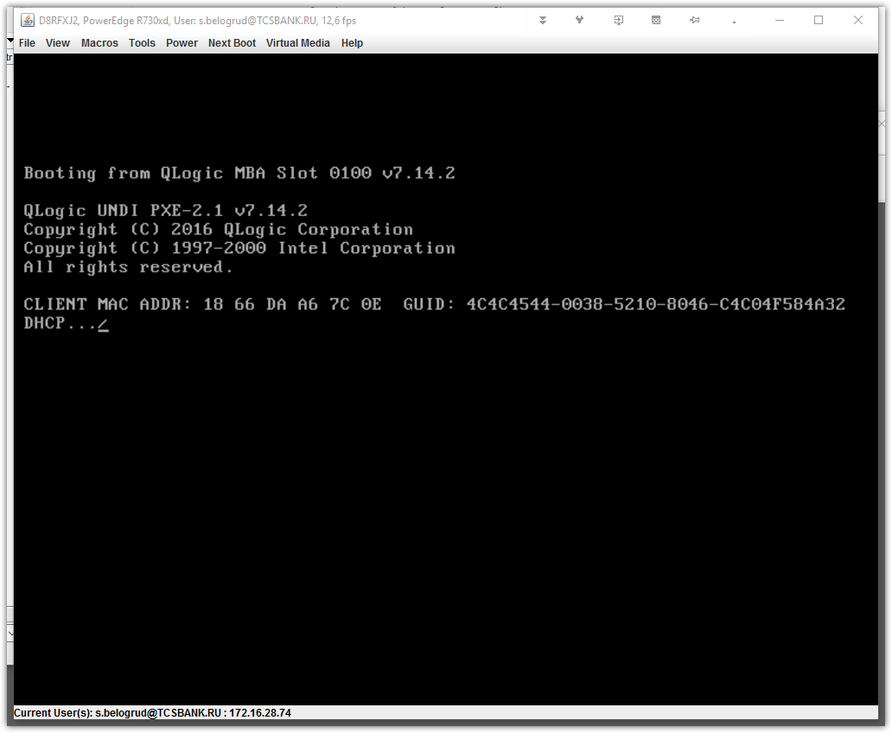

# The option of booting via PXE could be turned off in Lifecycle controller inside network card configuration.
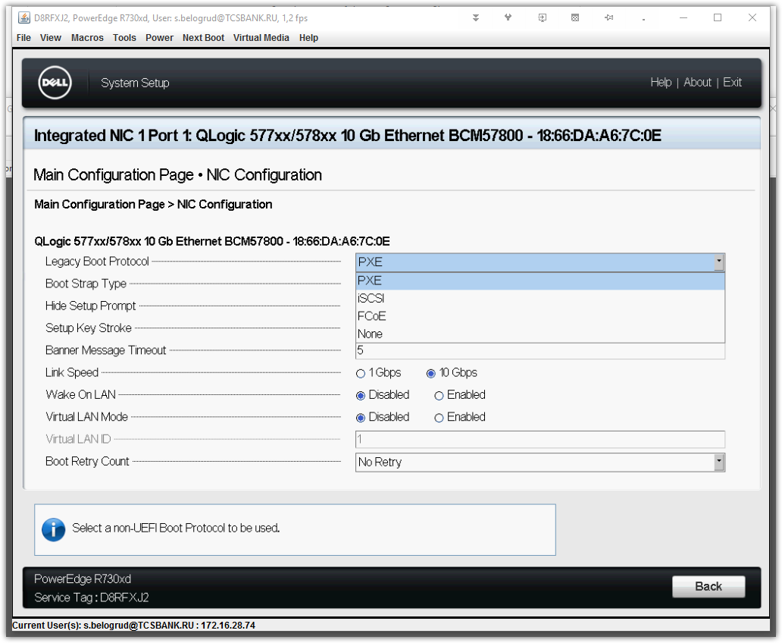

# In same configuration point we can check and turn off FCoE, but it turned off by default.

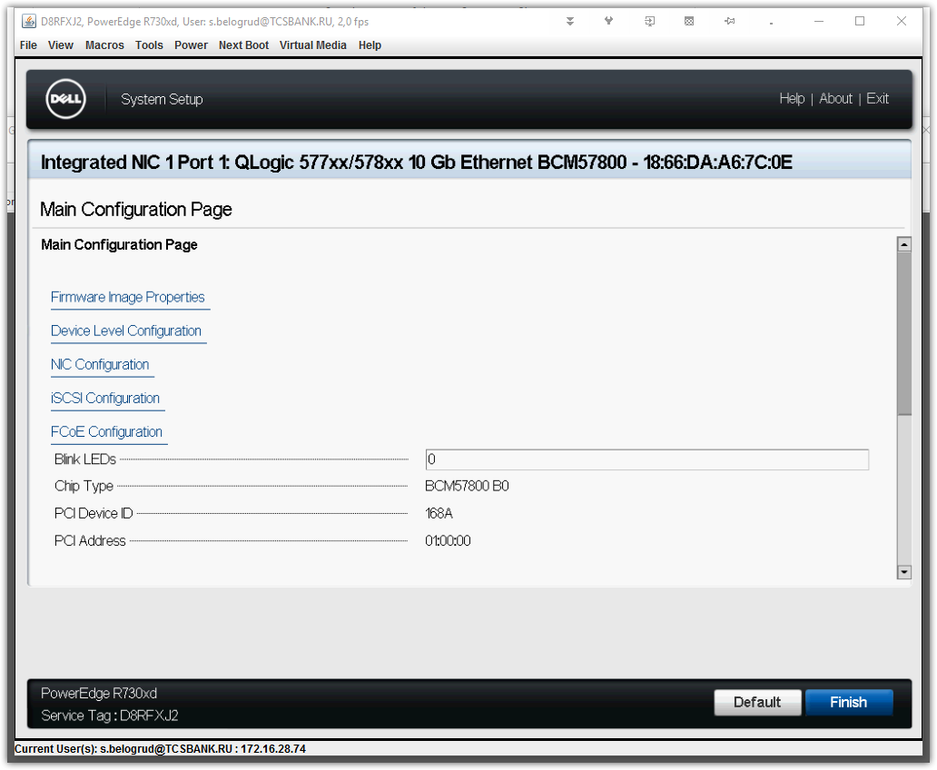
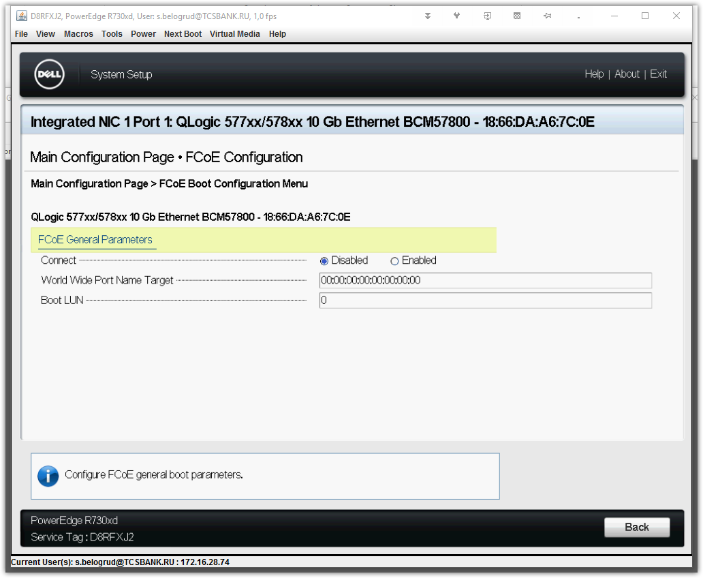

# Here is how it looks if not found booting partition.
# It’s happened after fixing raid problems.
# A sequence of raid-controller during boot was changed. Wrong raid-controller became first.
